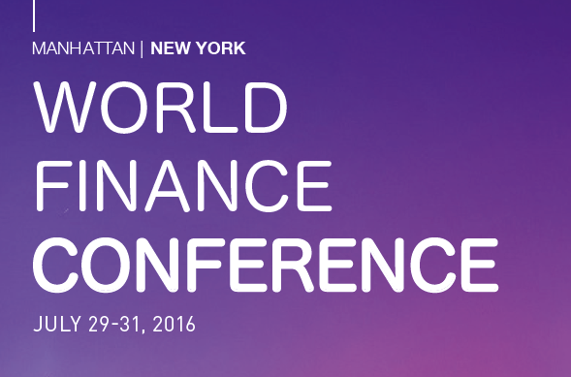

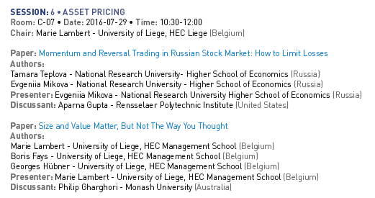

https://www.world-finance-conference.com/conference.php?id=3

2016 World Finance Conference New York (July 29-31, 2016), paper «Momentum and Reversal Trading in Russian Stock Market: How to Limit Losses»

